Jenkins 2
1.Configure 2 slave machines in the Jenkins master.
Objective
Configure two separate machines as Jenkins agents:
Jenkins Master
|
+---- Agent-1
|
+---- Agent-2
The agents will execute Jenkins jobs instead of the master.

Step 1. Create Agent EC2 Instances
If you already have two Linux EC2 instances, you can use them.
Otherwise create:
Agent 1
Recommended:
Name: Jenkins-Agent-1
OS: Amazon Linux 2023
Instance type: t3.micro/t2.micro depending on availability
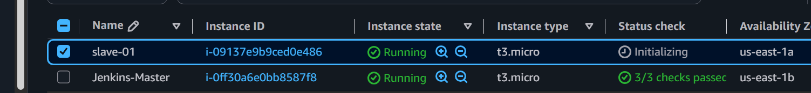
Agent 2
Name: Jenkins-Agent-2
OS: Amazon Linux 2023
Instance type: t3.micro/t2.micro depending on availability
For a lab, both can be small instances.Step 2. Configure Security Group
The agents need to communicate with the Jenkins master.
For an SSH-based Jenkins agent, allow:
Type: SSH
Protocol: TCP
Port: 22
Source: Jenkins Master Security Group
You can temporarily use the Jenkins master's private IP for a lab.
Example: Custom TCP
Port: 22
Source: 10.0.x.x/32
Better: SSH
Port: 22
Source: Jenkins-Master-SG
Important
Do not expose SSH to:
0.0.0.0/0
unless you're doing a temporary lab and understand the security implications.Step 3. Connect to Agent 1
SSH into Agent 1.
ssh -i your-key.pem ec2-user@<AGENT-1-PUBLIC-IP>
Check OS: cat /etc/os-release
Check hostname: hostnameStep 4. Install Java on Agent 1
Jenkins agents need Java.
Since your Jenkins environment is using Java 21, use Java 21 on the agents as well.
sudo dnf install java-21-amazon-corretto -y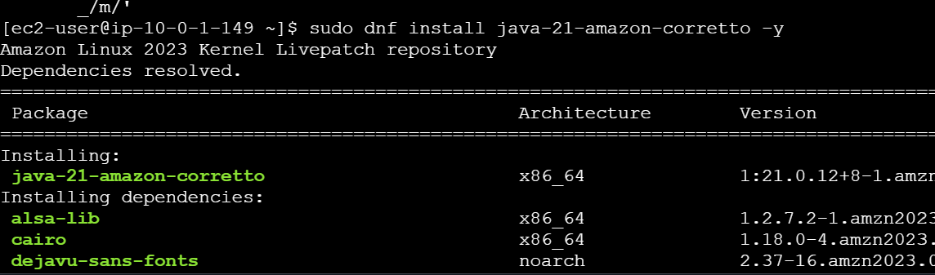
Verify: java -version
Expected:
openjdk version "21..."
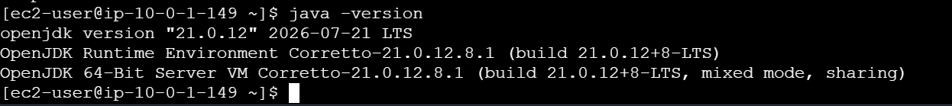
Find Java location: readlink -f $(which java)
You may see something similar to:
/usr/lib/jvm/java-21-amazon-corretto.x86_64/bin/javaStep 5. Create Jenkins Agent User
On Agent 1: sudo useradd -m jenkins
Set password if required: sudo passwd jenkins
Create Jenkins workspace: sudo mkdir -p /home/Jenkins
Set ownership: sudo chown -R jenkins:jenkins /home/jenkins
Check: id Jenkins
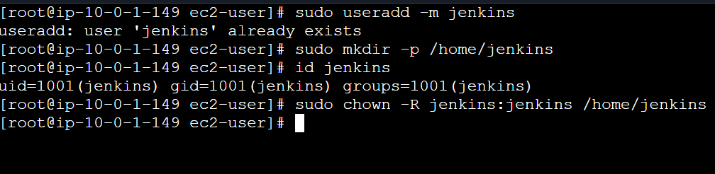Step 6. Repeat on Agent 2
SSH to Agent 2:ssh -i your-key.pem ec2-user@<AGENT-2-PUBLIC-IP>
Install Java: sudo dnf install java-21-amazon-corretto -y
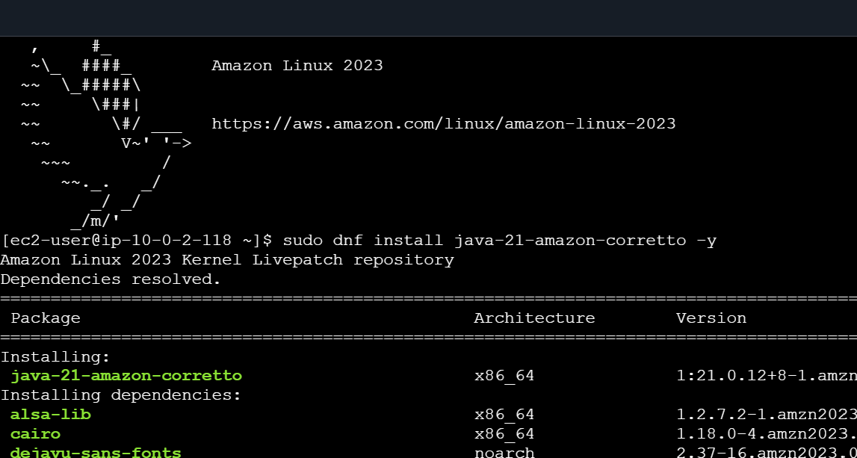
Verify: java -version
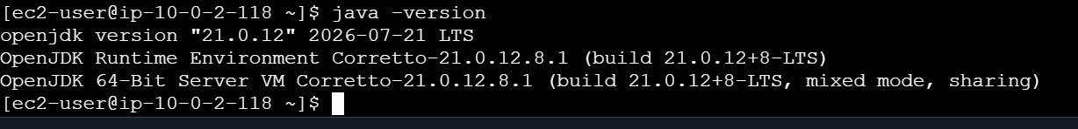
Create Jenkins user: sudo useradd -m jenkins
Create workspace:sudo mkdir -p /home/jenkins
Set ownership:sudo chown -R jenkins:jenkins /home/Jenkins
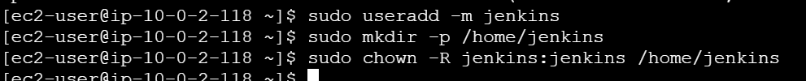Step 7. Generate SSH Key on Jenkins Master
Go to Jenkins Master.
Check whether an SSH key already exists:
sudo ls -la /var/lib/jenkins/.ssh/
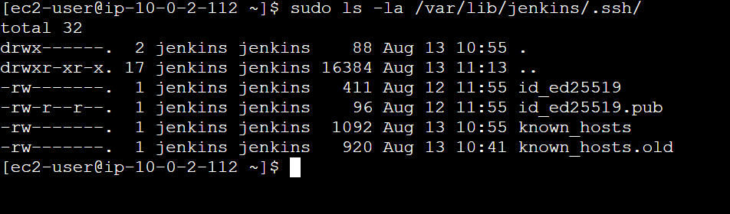
cat ~/.ssh/id_ed25519.pub
Copy the complete public key.
It will look similar to: ssh-ed25519 AAAAC3... jenkins@master
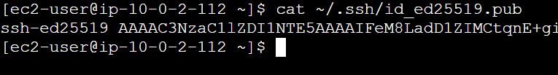Step 8. Add Jenkins Public Key to Agent 1
On Agent 1:
sudo su - jenkins
Create SSH directory:
mkdir -p ~/.ssh
chmod 700 ~/.ssh
Edit: vi ~/.ssh/authorized_keys
Paste the Jenkins master's public key.
Save.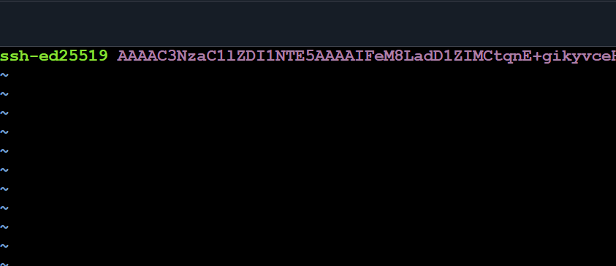
Set permissions:
chmod 600 ~/.ssh/authorized_keys
Exit:
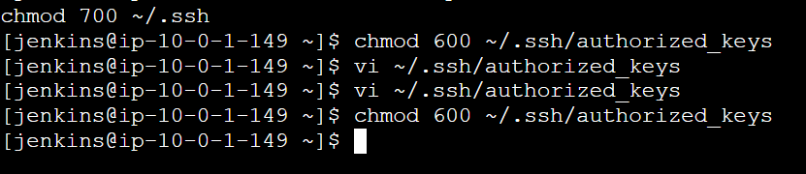Step 9. Repeat for Agent 2
On Agent 2:
sudo su - jenkins
mkdir -p ~/.ssh
chmod 700 ~/.ssh
Edit: vi ~/.ssh/authorized_keys
Paste the Jenkins master public key.
Then: chmod 600 ~/.ssh/authorized_keys
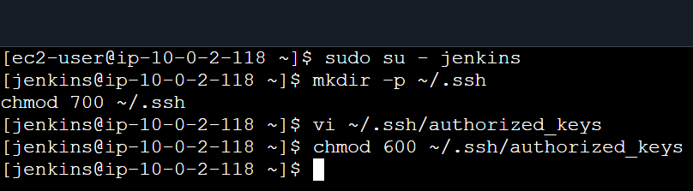Step 10. Test SSH from Jenkins Master
From Jenkins Master: sudo -u jenkins ssh jenkins@<AGENT-1-PRIVATE-IP>
You should get a shell on Agent 1.
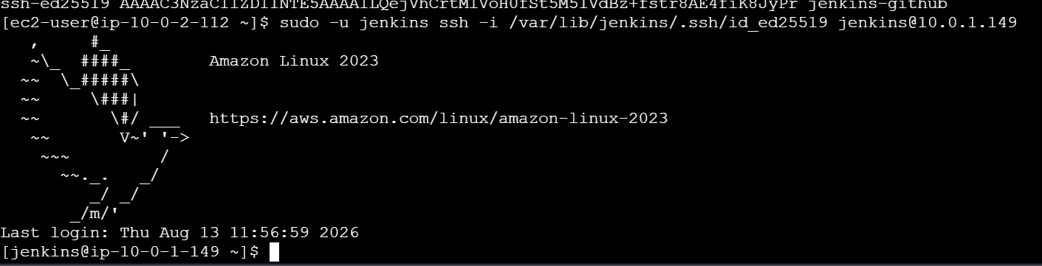
Test Agent 2: sudo -u jenkins ssh jenkins@<AGENT-2-PRIVATE-IP>
If successful:[ec2-user@agent2 ~]$
Exit.
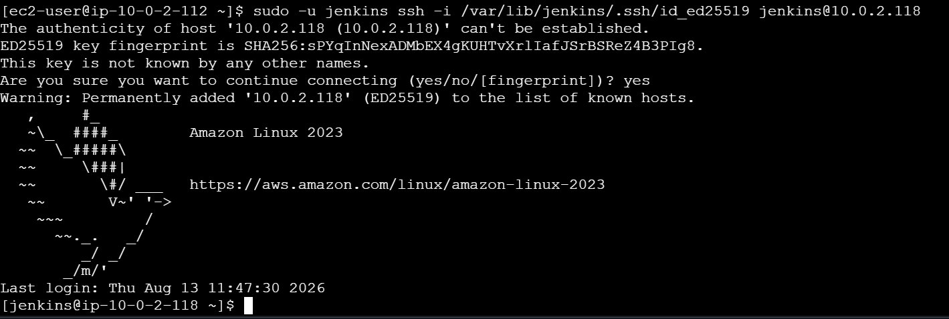Step 11. Add Agent 1 in Jenkins
Open:
Jenkins
↓
Manage Jenkins
↓
Nodes
Depending on your Jenkins version:
Manage Jenkins
↓
Manage Nodes and Clouds
Click: New Node
Enter: Node name:
jenkins-agent-1
Select: Permanent Agent
Click: CreateStep 12. Configure Agent 1
Configure: Number of executors
For a lab:1
Remote root directory
/home/jenkins
Labels Java
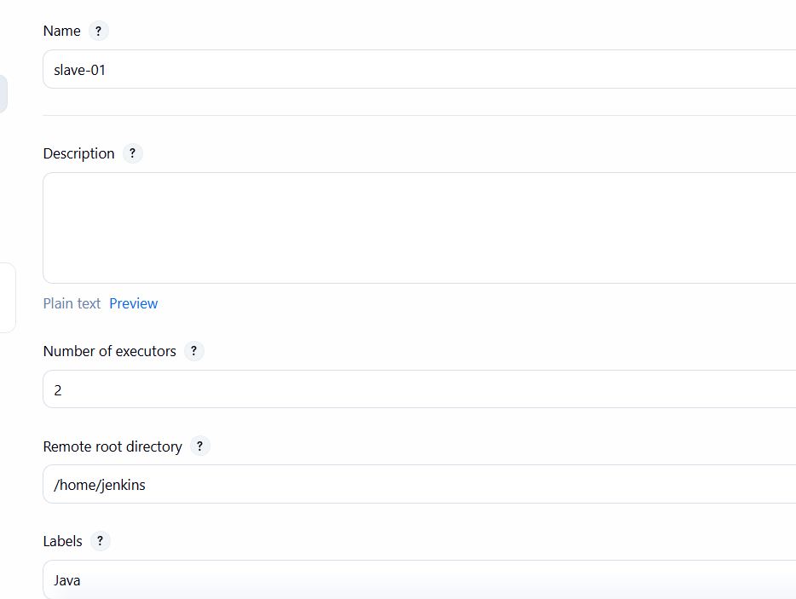
Usage
Select: Use this node as much as possible
Launch method
Select: Launch agents via SSH
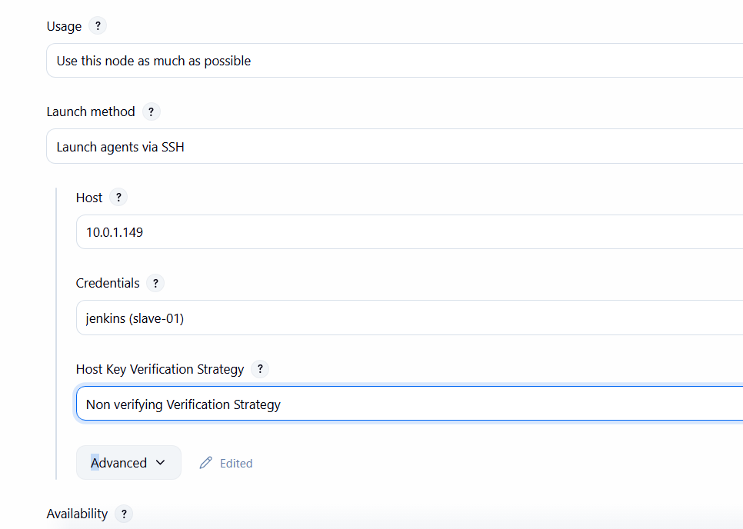
Step 13. Configure SSH Connection
Enter:
Host:<AGENT-1-PRIVATE-IP>
For credentials click: Add → Jenkins
Create credential: Kind: SSH Username with private key
Username: Jenkins
Private Key: Enter directly
Paste the private key from Jenkins Master:
sudo cat /var/lib/jenkins/.ssh/id_ed25519
Do not paste the .pub key.
Give credential an ID such as: jenkins-agent-key
Select it.
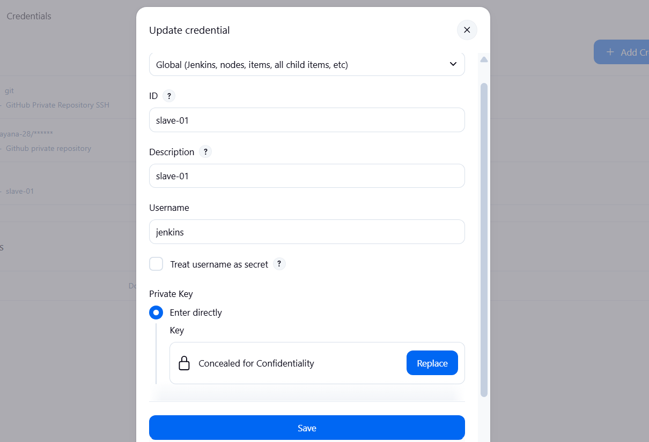
Host Key Verification Strategy:
For a controlled lab you can use:
Non verifying Verification Strategy
For production, use proper host-key verification instead.
Click:Save
Step 14 — Test slave-01
Now create a small test job.
Go to: Jenkins Dashboard→ New Item
Enter: Agent-01-Test
Select: Freestyle project
Click OK. 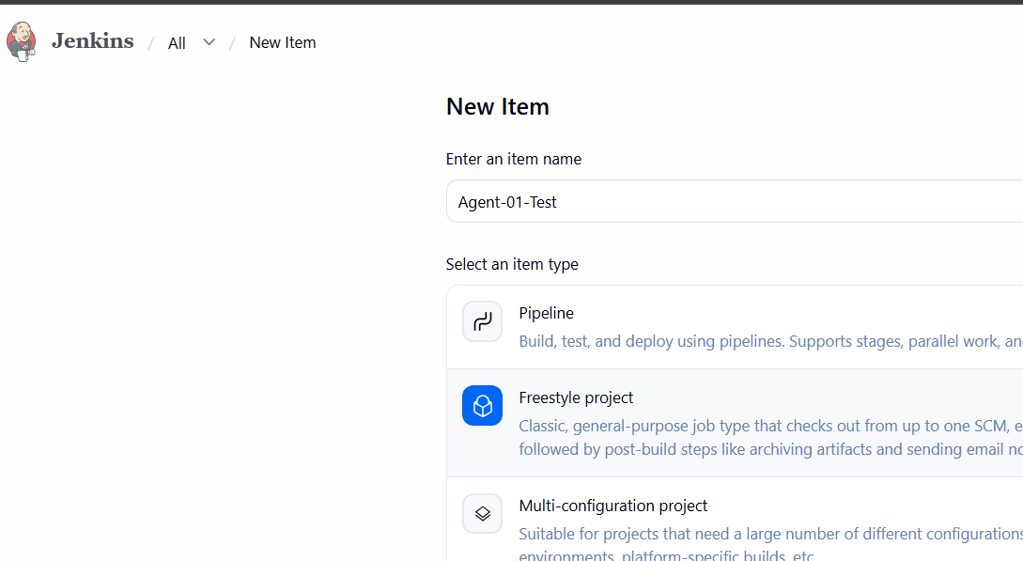
Restrict the job to slave-01
Inside the job configuration, find:General
Enable:Restrict where this project can be run
Enter: Java
Because your slave-01 label is currently: Java
Jenkins should recognize it.
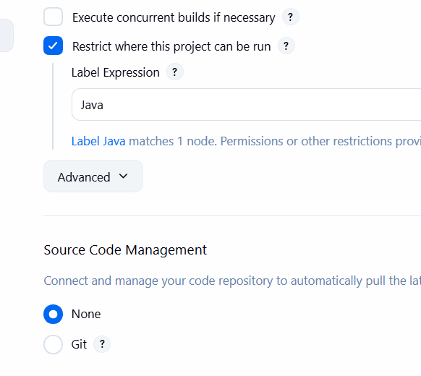
Add a build step
Go to: Build Steps
→ Add build step
→ Execute shell
Enter: echo "===== Jenkins Agent Test ====="
echo "Hostname:"
hostname
echo "Current User:"
whoami
echo "Java Version:"
java -version
echo "Working Directory:"
pwd
echo "Jenkins Workspace:"
echo $WORKSPACE
Click Save.
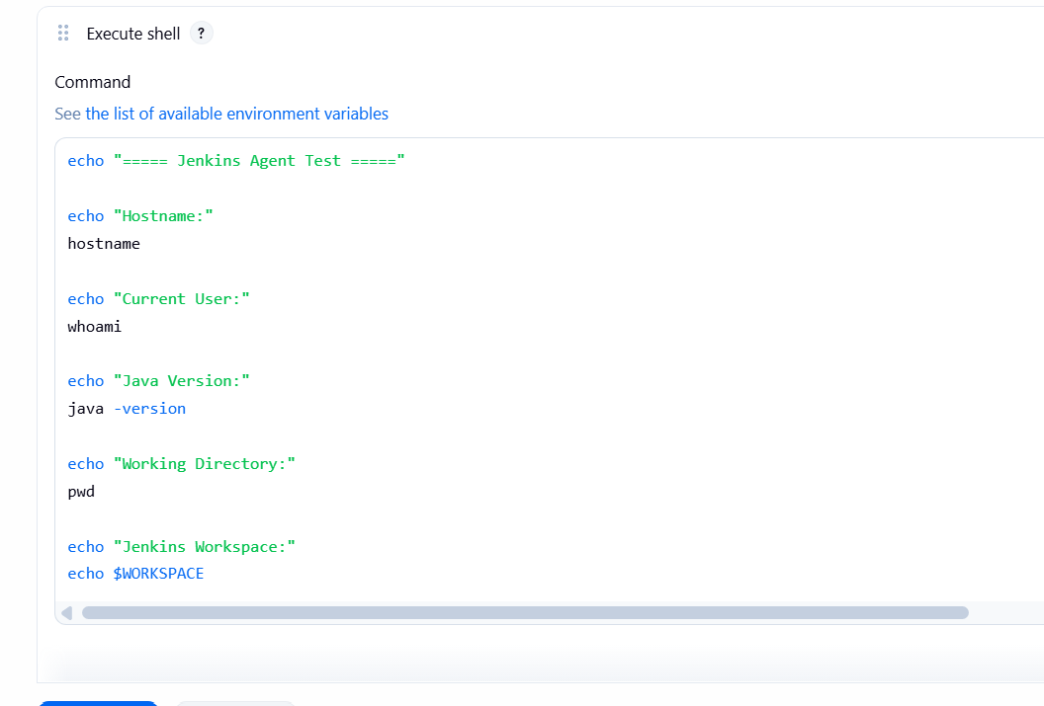Build the job
Click: Build Now
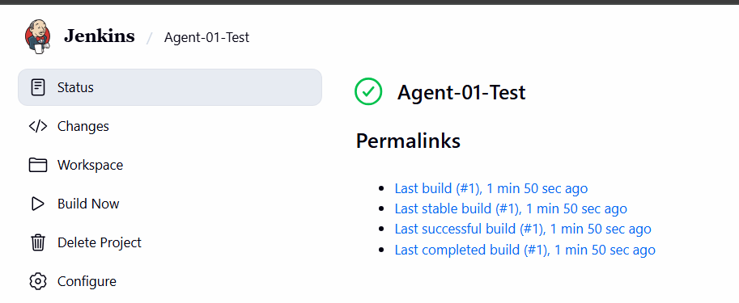
Then click: Build #1
→ Console Output
You should see something similar to:
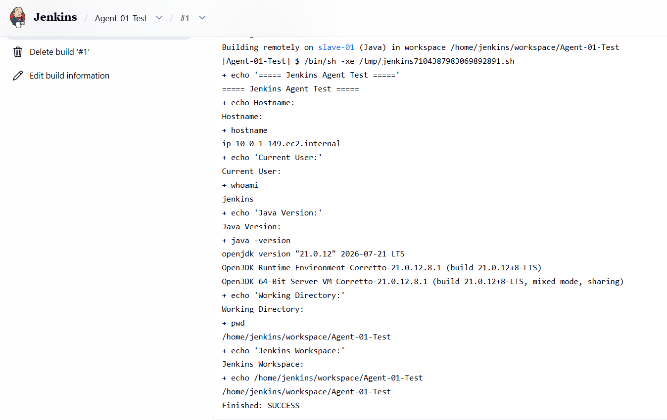
Step 15. Configure Agent 2
Repeat exactly the same procedure.
Node name:slave-02
Remote root: /home/Jenkins
Label:Java-1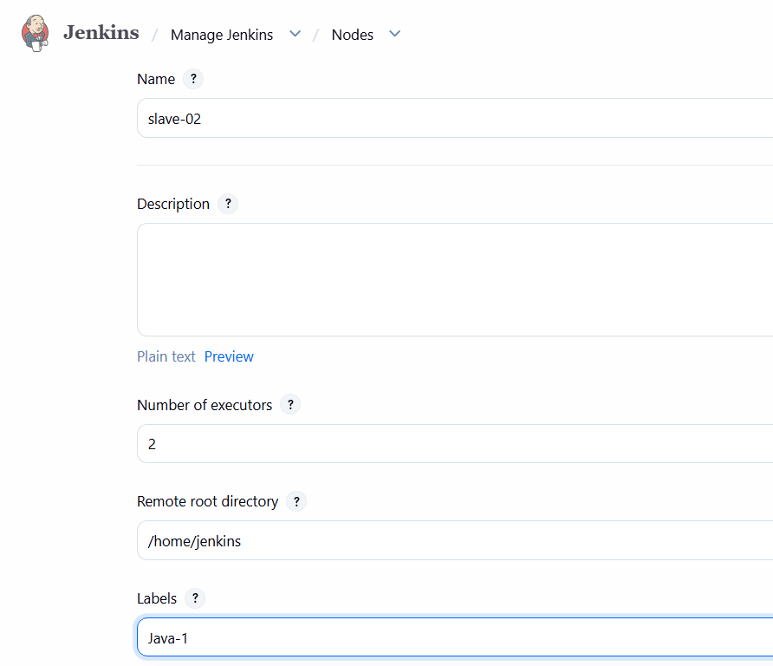
Host:<AGENT-2-PRIVATE-IP>
Credentials: jenkins-agent-key
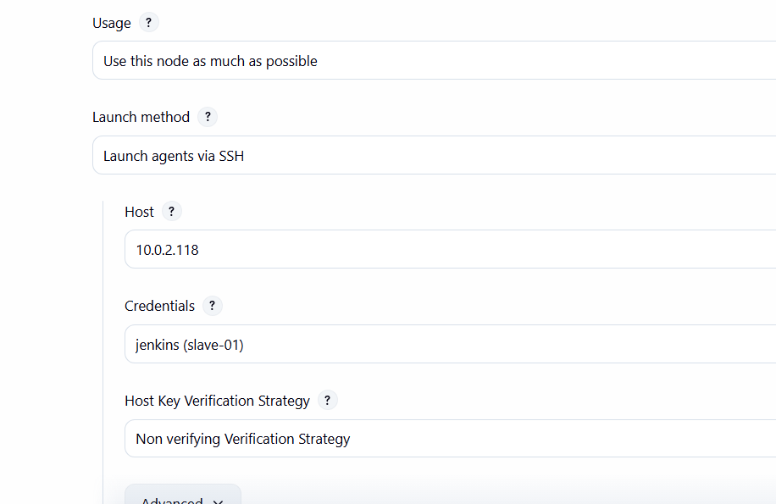
Save.Step 16. Verify Both Agents
You should eventually see:
Built-In Node
jenkins-agent-1 Connected
jenkins-agent-2 ConnectedStep 17. Test Agent Execution
Create: New Item
Name: Agent-Test
Select: Freestyle project
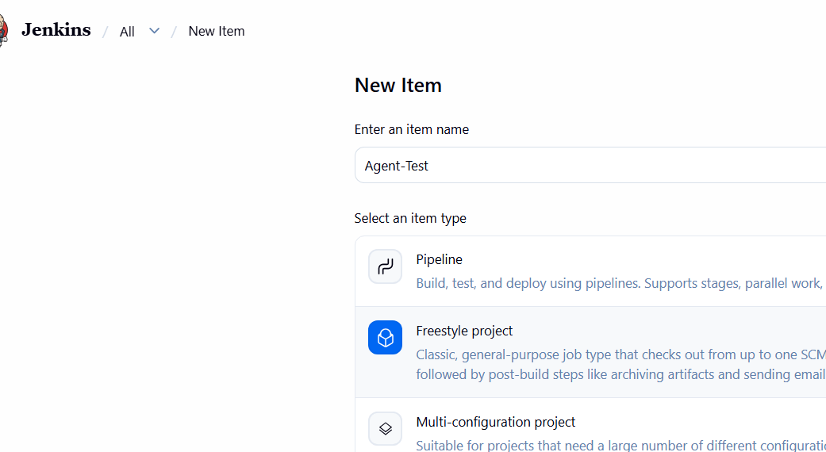
Under: General
enable: Restrict where this project can be run
Enter: linux-agent-1
Under: Build Steps
select: Execute shell
Add: echo "Running Jenkins job"
hostname java -version
pwd Save.
Click: Build Now
Open: Console Output
You should see the hostname of Agent 1.
This proves that Jenkins Master is delegating work to Agent
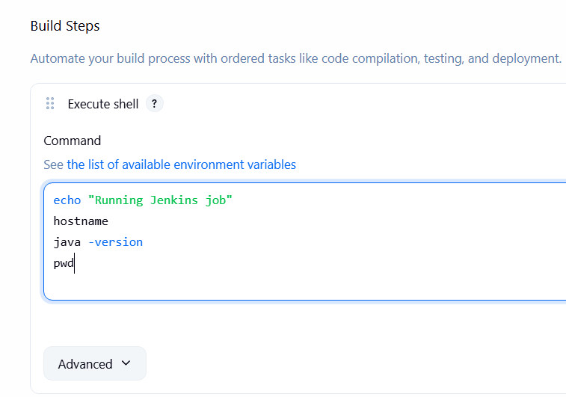
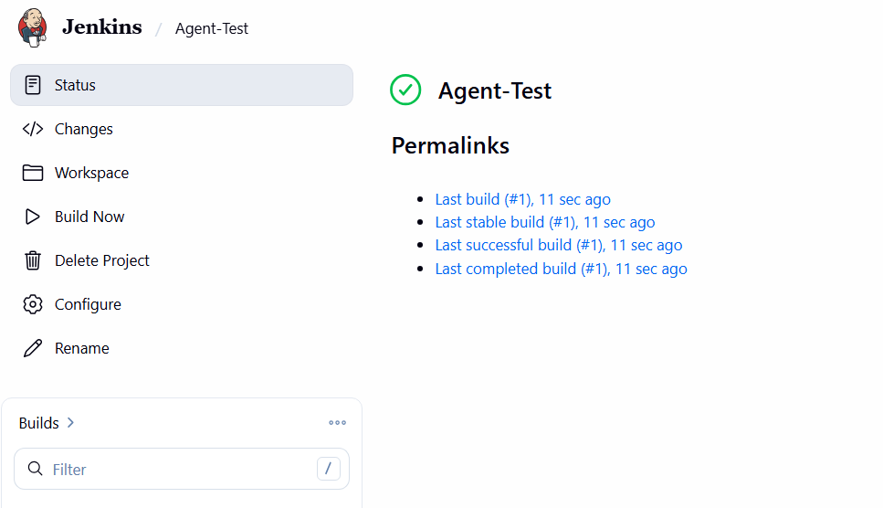
2. Configure webhooks to the Jenkins job.
GitHub → Jenkins Webhook — Detailed Steps
1. GitHub Webhook
• Open your GitHub Repository
• Go to Settings → Webhooks
• Click Add webhook
• Enter:
Payload URL: http://<JENKINS-IP>:8080/github-webhook/
Content type: application/json
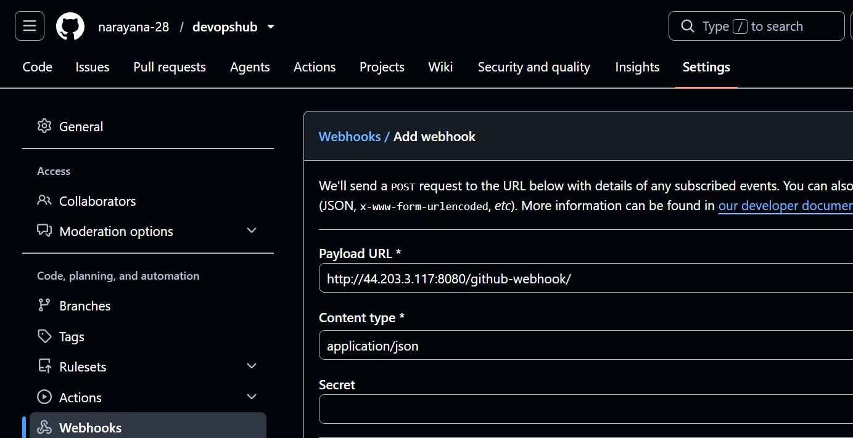
• Select Send me everything
• Keep Active checked
• Click Add webhook
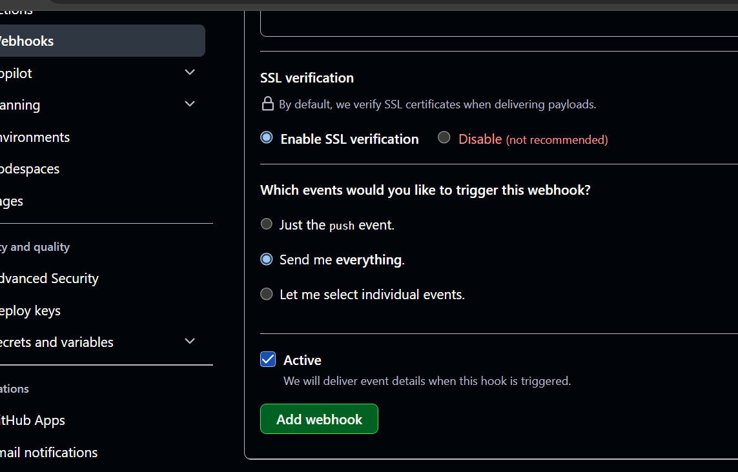
2. Create Jenkins Job
• Jenkins → New Item
• Enter Job Name
• Select Freestyle project
• Click OK
3. Configure GitHub Repository
• Go to Source Code Management
• Select Git
• Enter the GitHub repository URL
• Add credentials if the repository is private
• Branch:*/main
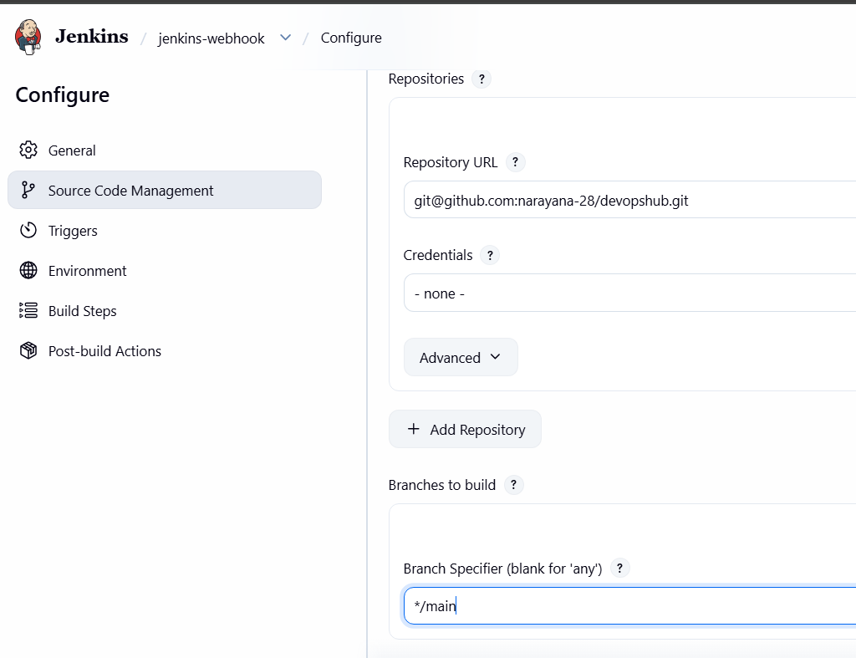
Save
• Click Apply → Save
- Click on Build Now
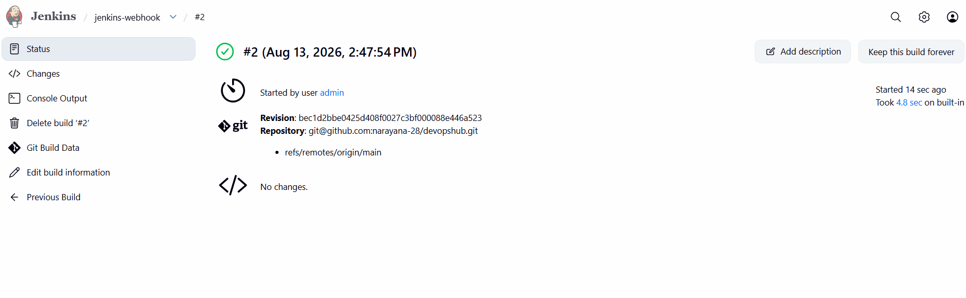
3. Now try to configure Jenkins-webhook in build -triggers
Select : GitHub hook trigger for GITScm polling
Now go to your respository change readme file some text and commit the changes in your github respository and check the Jenkins job run automatically as you see in ss below
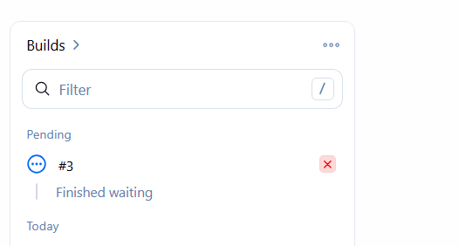
Then you can see build get succeded
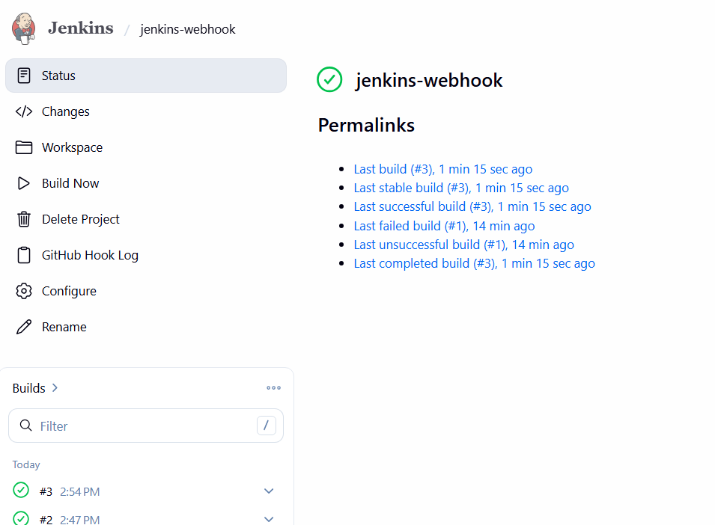
3. Configure Poll SCM and Build Periodically options in the Jenkins job.
Job-02 — Poll SCM & Build Periodically
1. Jenkins → New Item → Job-02 → Freestyle → OK
2. Source Code Management → git@github.com:narayana-28/devopshub.git
3. Select SSH credentials
Jenkins → Manage Jenkins → Credentials
Select Global → Add Credentials
Kind: SSH Username with private key
Username: git
Private Key: paste the contents of:
cat /var/lib/jenkins/.ssh/id_ed25519
ID: github-ssh
Click Create
4. Branch: */main
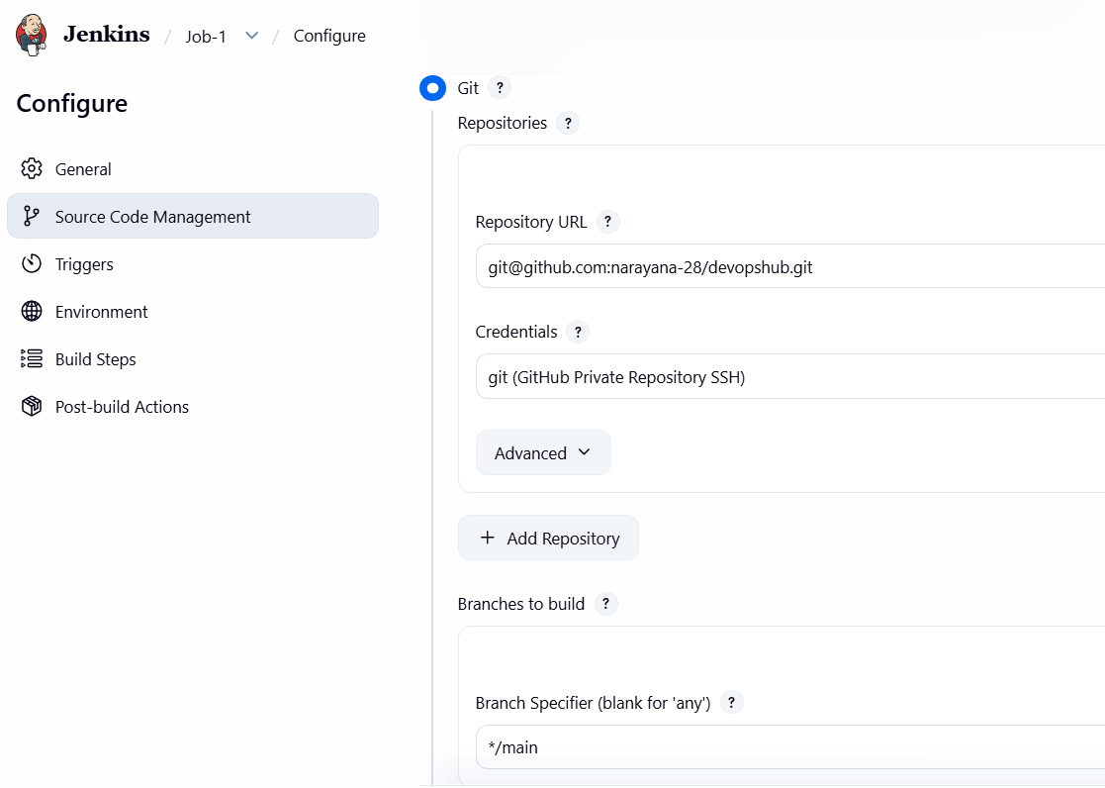
5. Build Triggers → Poll SCM
H/5 * * * *
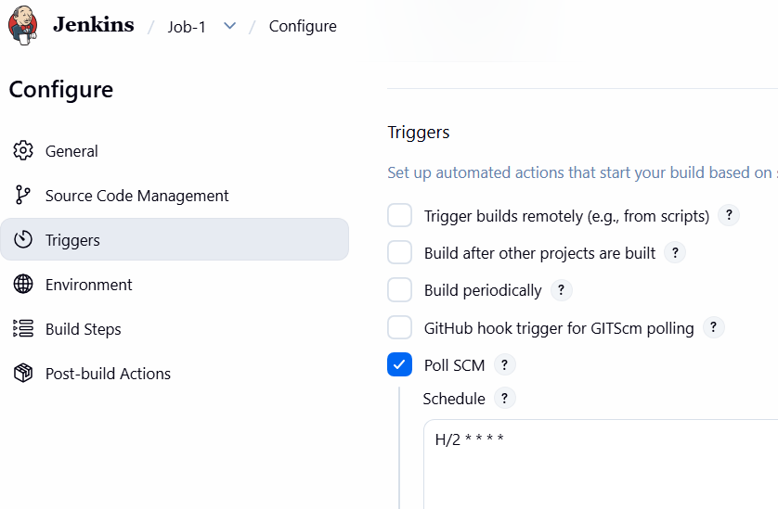
6. Click on Build Now
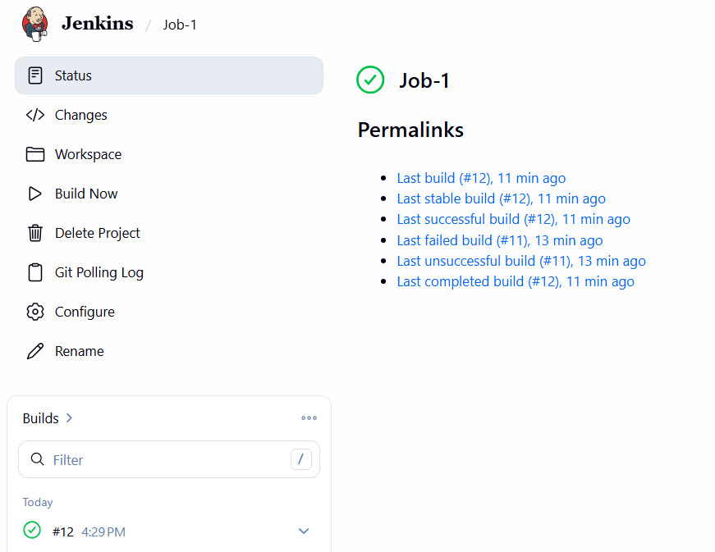
7. Go to GitHub -→ repo and make some changes
8. Build periodically
H 1 * * *
9. Apply → Save → Build Now
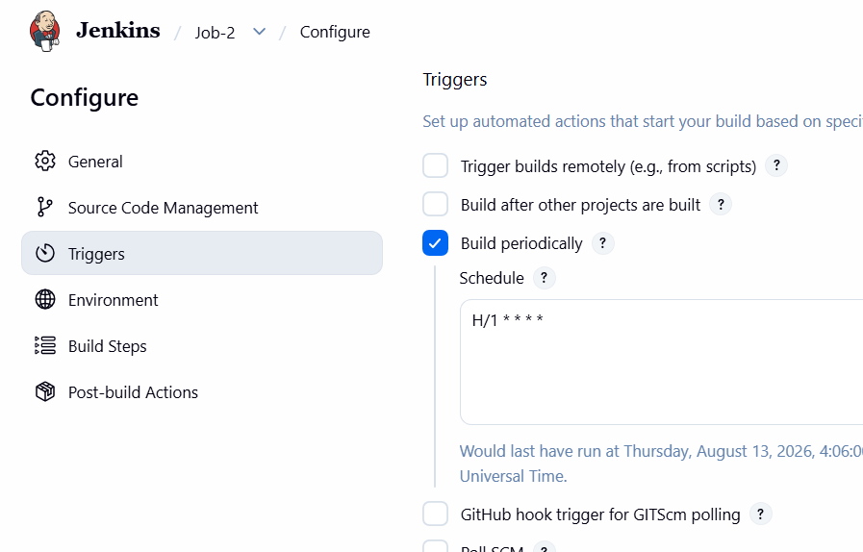
4.Take a backup of the Jenkins server using a bash-script.
Jenkins Server Backup Using Bash Script
Now we will create a proper Jenkins backup script.What Should Be Backed Up?
The most important Jenkins data is stored under:
/var/lib/jenkins
This normally contains:
jobs/
users/
plugins/
credentials/
secrets/
config.xml
nodes/
among other Jenkins configuration/state.
Important: Jenkins secrets and credentials are stored in this directory, so the backup must be protected.Step 1. Check Jenkins Home
Run: echo $JENKINS_HOME
If nothing is returned: sudo systemctl show jenkins -p Environment
For your setup it is likely: /var/lib/jenkins
Verify: sudo ls -lah /var/lib/jenkins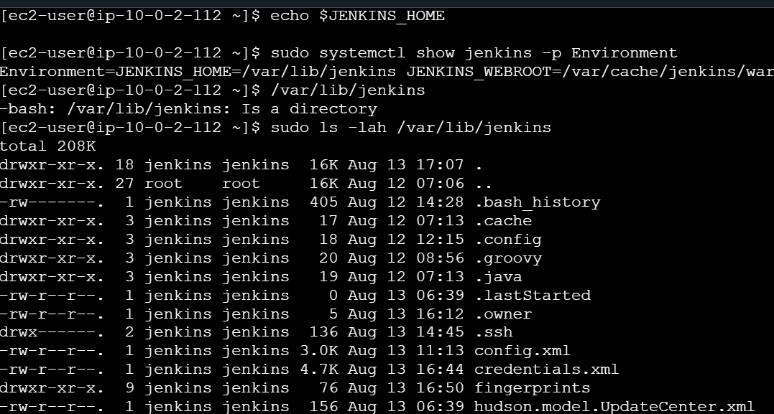

Step 2. Create Backup Directory
sudo mkdir -p /backup/jenkins
Set permissions:
sudo chmod 700 /backup/Jenkins
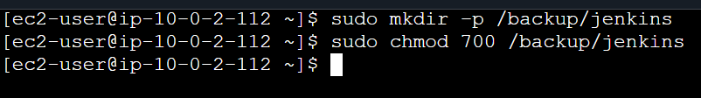

Step 3. Create Backup Script
Create: sudo vi /usr/local/bin/jenkins-backup.sh
Use: #!/bin/bash
set -e
JENKINS_HOME="/var/lib/jenkins"
BACKUP_DIR="/backup/jenkins"
DATE=$(date +%Y-%m-%d_%H-%M-%S)
BACKUP_FILE="${BACKUP_DIR}/jenkins-backup-${DATE}.tar.gz"
echo "========================================"
echo "Jenkins Backup Started"
echo "Date: $(date)"
echo "========================================"
mkdir -p "$BACKUP_DIR"
echo "Creating Jenkins backup..."
tar -czpf "$BACKUP_FILE" \
-C "$JENKINS_HOME" .
echo "Backup completed successfully."
echo "Backup file:"
echo "$BACKUP_FILE"
echo "Backup size:"
du -h "$BACKUP_FILE"
echo "Removing backups older than 7 days..."
find "$BACKUP_DIR" \
-type f \
-name "jenkins-backup-*.tar.gz" \
-mtime +7 \
-delete

echo "========================================"
echo "Jenkins Backup Finished"
echo "========================================"
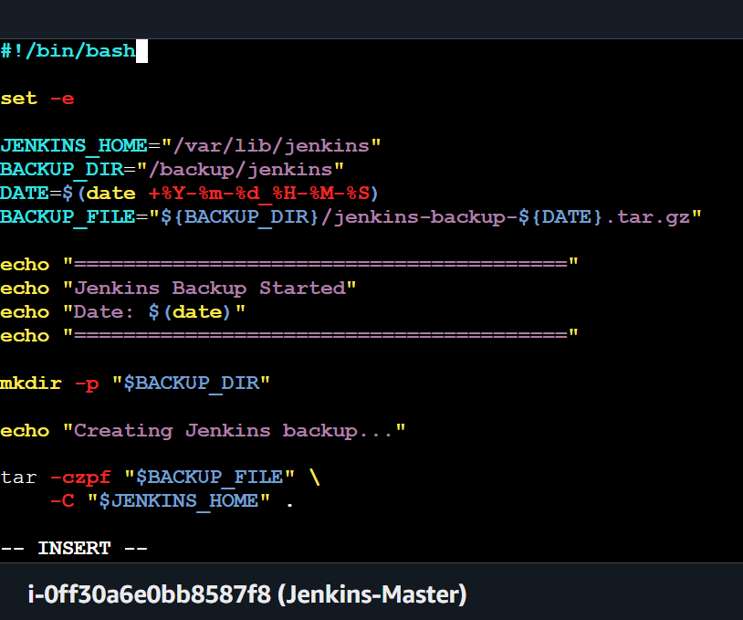

Step 4. Give Execute Permission
sudo chmod +x /usr/local/bin/jenkins-backup.sh
Verify:
ls -l /usr/local/bin/jenkins-backup.sh
You should see execute permission.
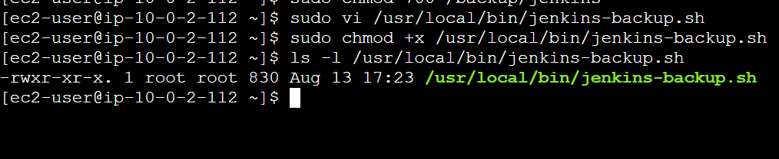
Step 5. Run Backup
Execute:
sudo /usr/local/bin/jenkins-backup.sh
Expected:
Jenkins Backup Started
Creating Jenkins backup...
Backup completed successfully.
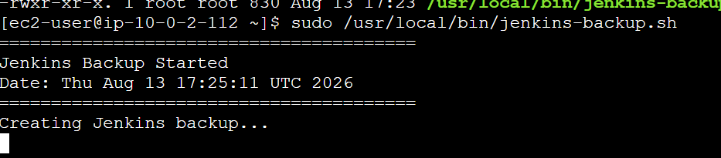
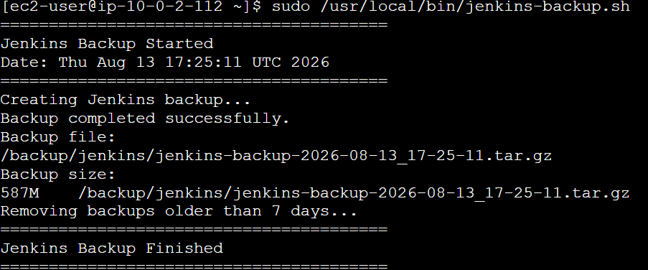

Step 6. Verify Backup
sudo ls -lh /backup/jenkins/
Example:
jenkins-backup-2026-08-12_21-30-00.tar.gz
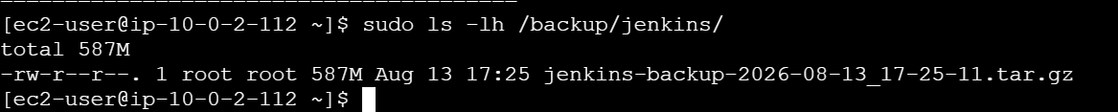Step 7. Check Backup Contents
Don't extract it yet.
Use:
sudo find / -type f -name "jenkins-backup-*.tar.gz" 2>/dev/null
sudo tar -tzf /backup/jenkins/jenkins-backup-2026-08-13_17-25-11.tar.gz | head -30
You should see files such as:
./config.xml
./jobs/
./users/
./plugins/
./secrets/
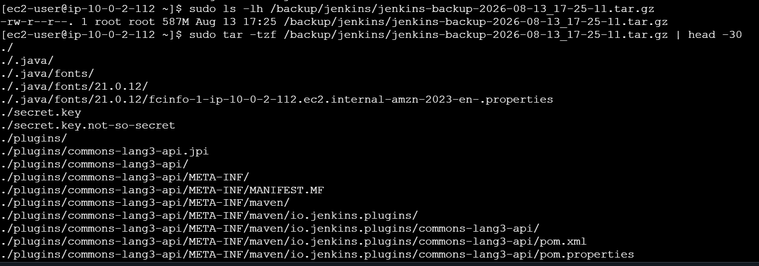

Task 5 — Jenkins ThinBackup Plugin
The objective is to take a Jenkins backup using the ThinBackup plugin.
Step 1 — Open Plugin Manager
From Jenkins:
Dashboard → Manage Jenkins → Plugins
Go to:
Available plugins
Search for:
ThinBackup
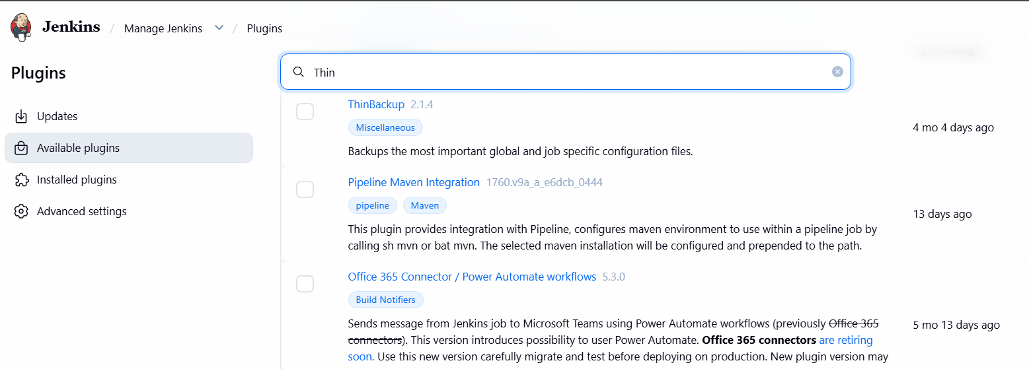
You should find:
ThinBackup
Install it.
Select:
Install without restart
Wait for the installation to complete.
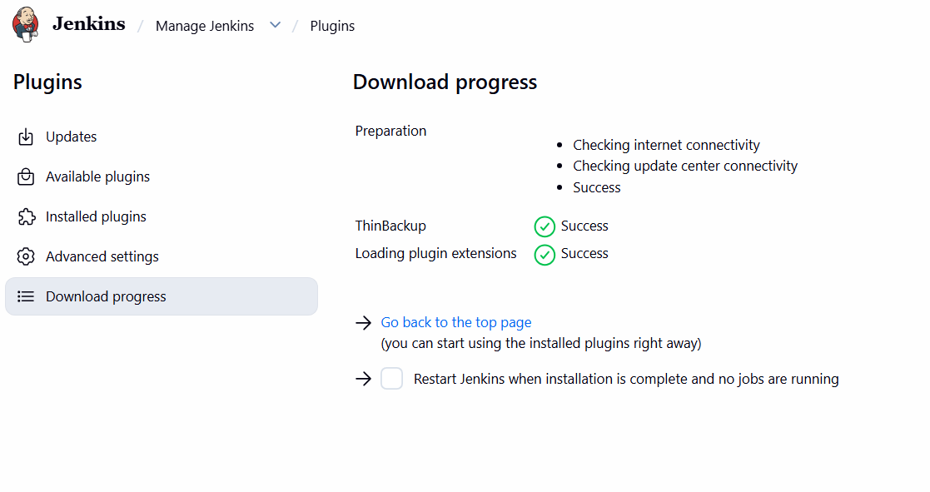

Step 2 — Verify ThinBackup
Go to:
Manage Jenkins
You should now see:
ThinBackup
or:
Manage Jenkins → ThinBackup
Click it.
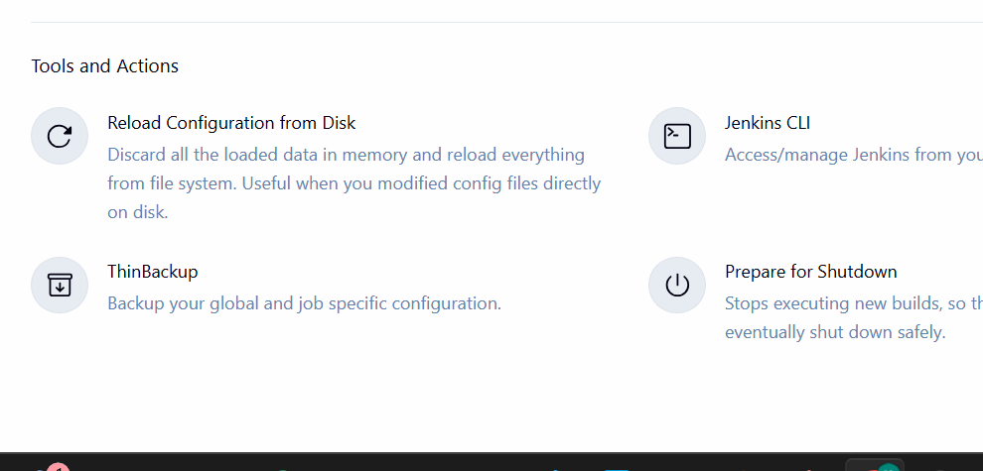

Step 3 — Configure ThinBackup
You should see a configuration page.
Look for:
Backup directory
Set it to:
/backup/thinbackup
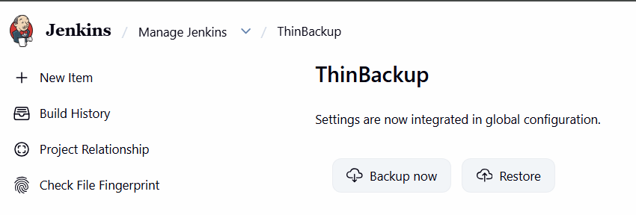
Create the directory first on the Jenkins Master:
sudo mkdir -p /backup/thinbackup
Set ownership:
sudo chown jenkins:jenkins /backup/thinbackup
Verify:
sudo ls -ld /backup/thinbackup
You want Jenkins to have write access.
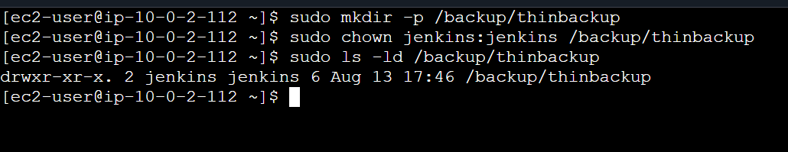

Step 4 — Configure backup options
For your hands-on lab, enable the options related to backing up Jenkins configuration.
Depending on your ThinBackup plugin version, the exact fields may differ.
Configure approximately:
Backup directory:
/backup/thinbackup
Enable:
Backup build results
if available.
Enable:
Backup fingerprints
if available.
Enable:
Backup user contents
if available.
For the lab, you can initially leave scheduling disabled because we'll perform a manual backup first.
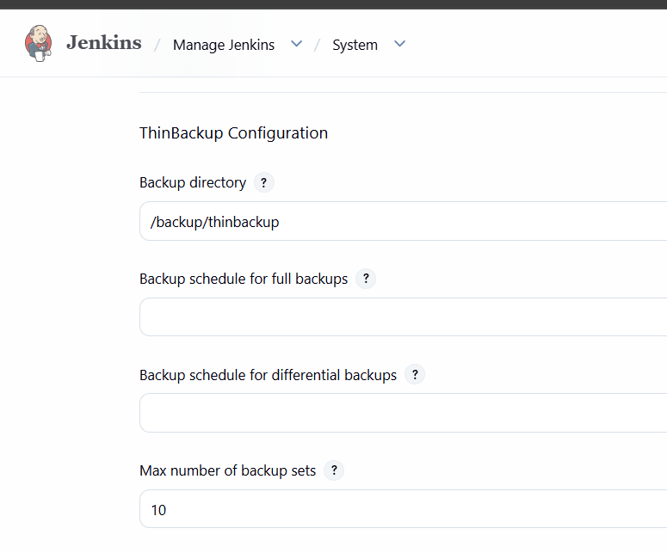

Step 5 — Save configuration
Click:
Save

Step 6 — Run ThinBackup manually
Go to:
Manage Jenkins → ThinBackup
Look for an option similar to:
Backup Now
Click:
Backup Now
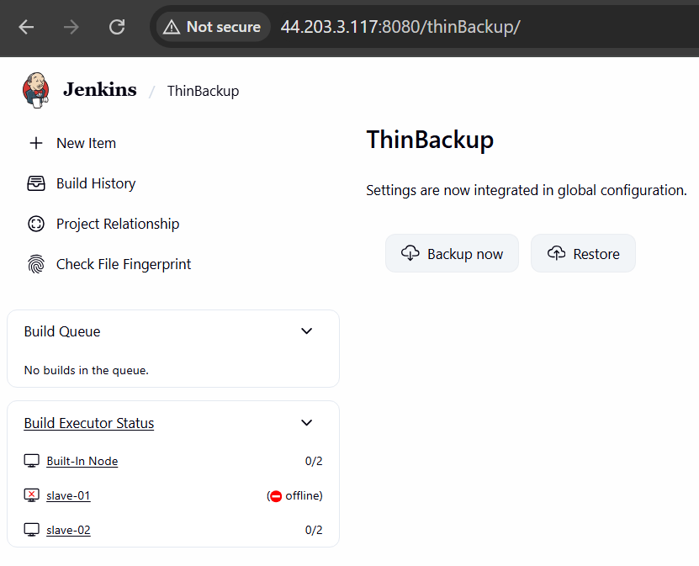
ThinBackup will create the backup in:
/backup/thinbackup

Step 7 — Verify from Linux
On the Jenkins Master:
sudo ls -lah /backup/thinbackup/
You should see files/directories created by ThinBackup.
For example, depending on the plugin version:
2026-08-13_...
or similar timestamped backup content.
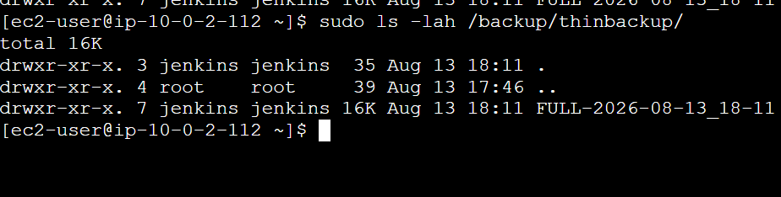

Step 8 — Check ownership
Run:
sudo ls -lah /backup/thinbackup/
Make sure the Jenkins process can access the backup directory.
You can also check:
sudo -u jenkins touch /backup/thinbackup/test-file
If that succeeds:
sudo rm -f /backup/thinbackup/test-file
This confirms Jenkins has write permission.

Step 9 — What ThinBackup does
Your two backup methods are different:
Jenkins Backup
|
+--------+--------+
| |
↓ ↓
Bash Script ThinBackup
| |
Full archive Jenkins-aware
| |
587 MB .tar.gz Backup directory
Bash backup
You manually backed up:
/var/lib/jenkins
into:
jenkins-backup-2026-08-13_17-25-11.tar.gz
ThinBackup
ThinBackup provides Jenkins-specific backup management and can be configured for scheduled backups.

Important for Task 6
Keep both backups:
/backup/jenkins/
└── jenkins-backup-2026-08-13_17-25-11.tar.gz
and:
/backup/thinbackup/
└── ThinBackup-generated backup
6. Set up a new Jenkins server and restore the backup taken in task 4.
Set up the new Jenkins server
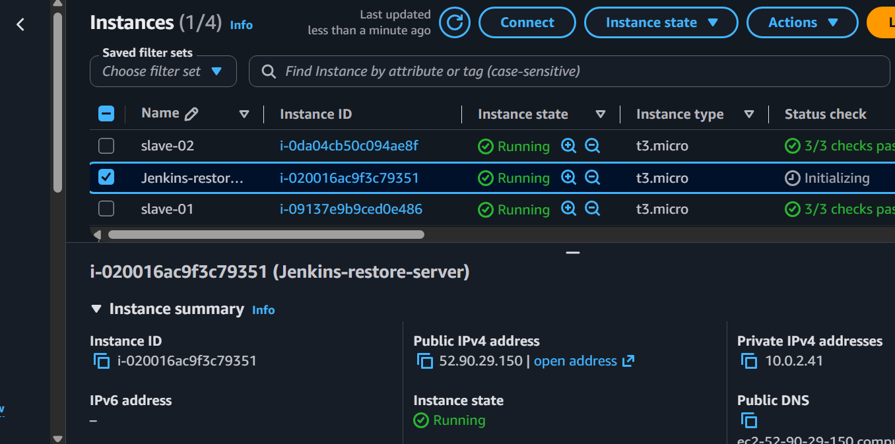
Install Jenkins on the new EC2 server and start it once:
1. Install Java
sudo dnf install java-21-amazon-corretto -y
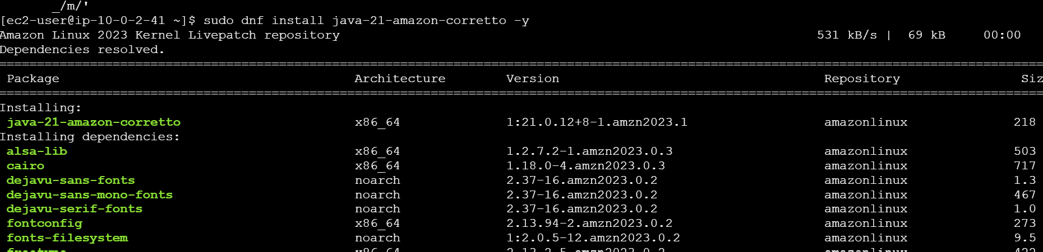
2.Add Jenkins repository
sudo wget -O /etc/yum.repos.d/jenkins.repo \
https://pkg.jenkins.io/redhat-stable/jenkins.repo
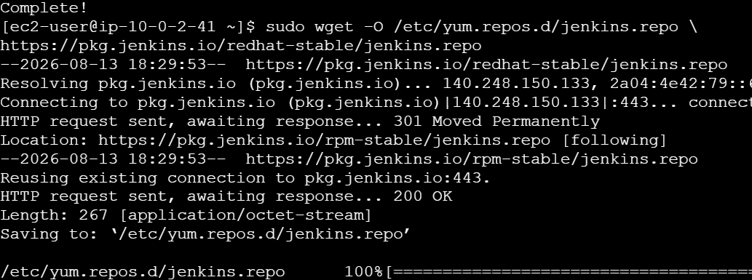
sudo rpm --import https://pkg.jenkins.io/redhat-stable/jenkins.io-2026.key
3. Install Jenkins
sudo dnf install jenkins -y
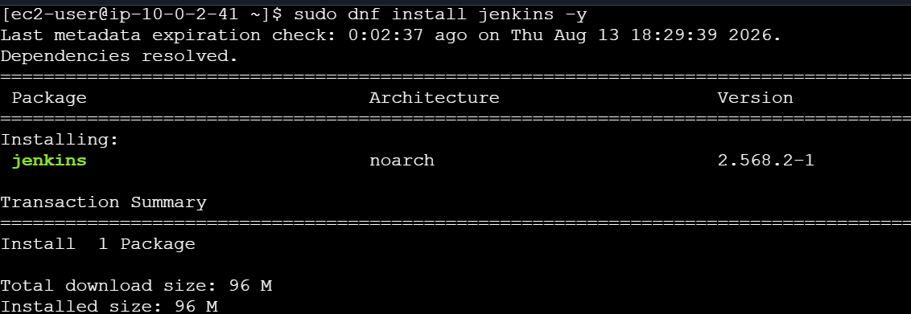
4. Stop Jenkins
sudo systemctl stop jenkins
5. Copy Task 4 backup to new server
Example:
scp -i ~/jenkins.pem \
ec2-user@10.0.2.112:/home/ec2-user/jenkins-backup-2026-08-13_17-25-11.tar.gz \
/home/ec2-user/
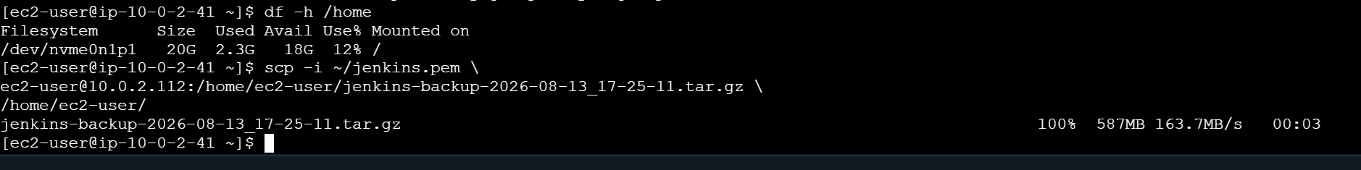
6. Verify backup on backup server
ls -lh /home/ec2-user/jenkins-backup-2026-08-13_17-25-11.tar.gz
sudo tar -tzf /home/ec2-user/jenkins-backup-2026-08-13_17-25-11.tar.gz | head -20
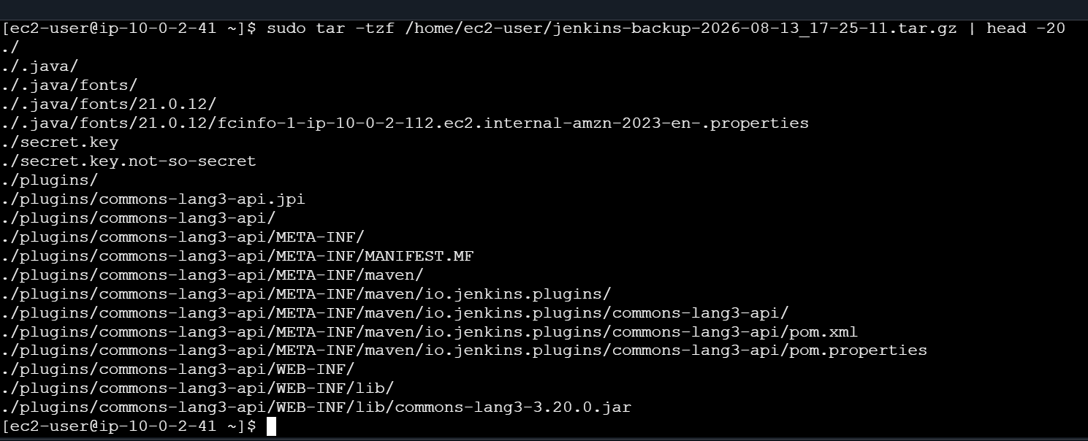
7. Move the new Jenkins directory
sudo mv /var/lib/jenkins /var/lib/jenkins-before-restore
8. Restore backup
ls -ld /var/lib/jenkins-before-restore
Then:
ls -ld /var/lib/jenkins
You should get:
No such file or directory
That's expected.
Extract the backup
Your backup was created from /var/lib/jenkins, so we need to extract it into /.
Run:
sudo tar -xzf /home/ec2-user/jenkins-backup-2026-08-13_17-25-11.tar.gz -C /
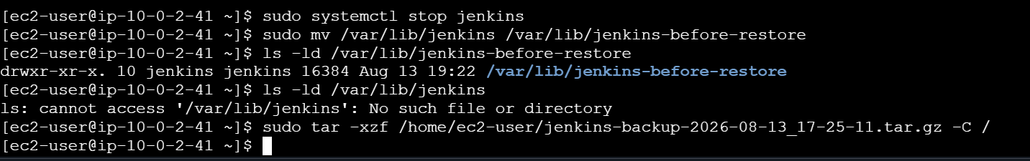
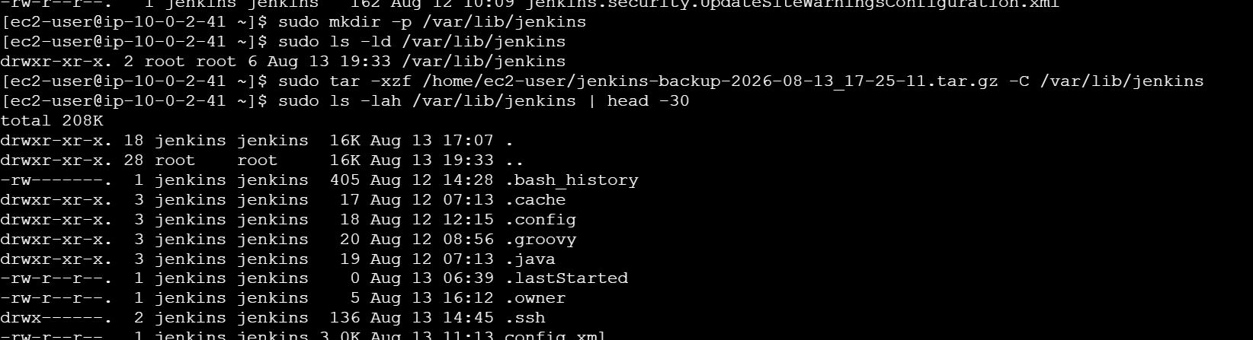
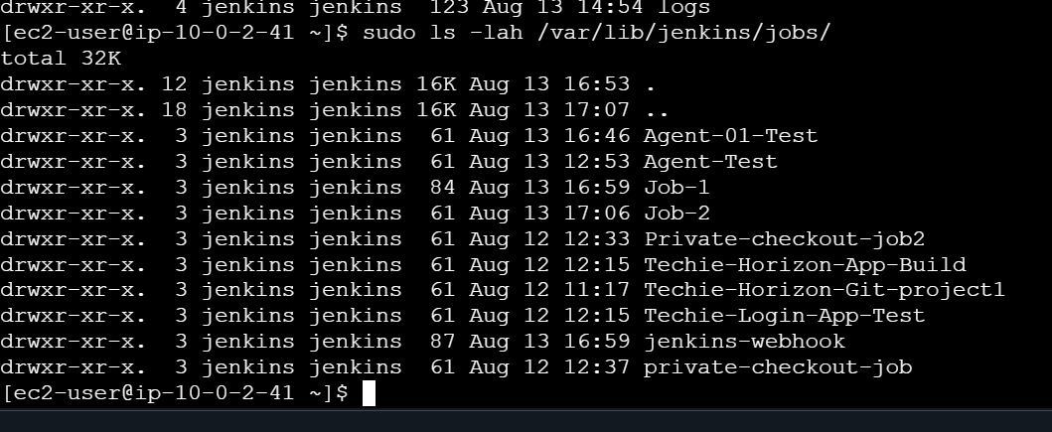
9. Fix permissions
sudo chown -R jenkins:jenkins /var/lib/Jenkins
10. Enable and start Jenkins
sudo systemctl enable jenkins
sudo systemctl start Jenkins
11. Check Jenkins
sudo systemctl status Jenkins
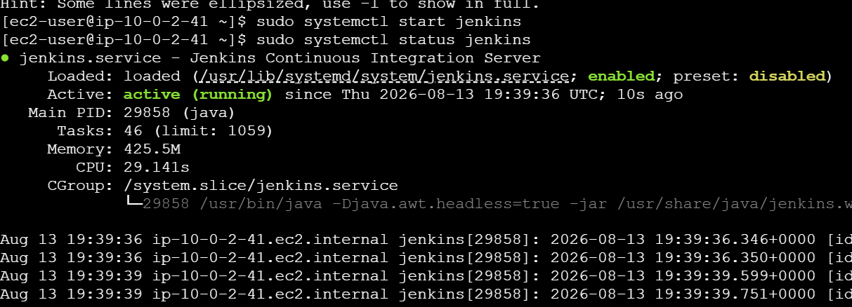
12. Open Jenkins
default port: http://NEW-SERVER-IP:8080
13. Verify restoration
Check that your old Jobs, configurations, users, build history, credentials, and plugins are available.
